- Do not edit/delete any heading or section with red text.
- Type /paste you answers in relevant sections (below Final Answer (in all questions , Approach (wherever required ) and Charts & tables (wherever required)) of the solution
- Link to submission guidelines
- Please note that submission not following the guidelines will not be accepted

OBJECTIVE QUESTIONS

Question 1: What is the total no. of attributes present in the data?

Solution:

Final Answer (if any):
16

Approach (if any):
Table 1:- ID ticket, Fecha, Employee ID, Agent ID, Request Category, Issue Type, Severity, Priority, Resolution Time (Days), Satisfaction Rate.
Table 2:- Agent I’D, Agent Name, Email I’d, Date of birth, Month of birth, Year of birth.

Charts & Tables (if any):
- Table / Chart Name:
<Name of the table or chart used>
- Description:
<What the table or chart represents>

Question 2: Which columns have inconsistent or missing values, and what is the count of such values?

Solution:

Final Answer (if any):
Column Severity in Ticket Table have inconsistent Value in Place of Major it is written has Mayor, and in that column there is Unclasified which will be Unclassified and in Column Priority there is unassiged which will be Unassigned.

Approach (if any):
=COUNTIF(G:G,"3 - Mayor")
=COUNTIF(G:G,G2)
=COUNTIF(H:H,H2)
Charts & Tables (if any):
- Table / Chart Name:
<Name of the table or chart used>
- Description:
<What the table or chart represents>

Question 3: What is the average daily ticket volume over time?

Solution:

Final Answer (if any):
53.36562671

Approach (if any):
=COUNTA(Tickets!A:A)/COUNT(UNIQUE(Tickets!B2:B97499))

Charts & Tables (if any):
- Table / Chart Name:
<Name of the table or chart used>
- Description:
<What the table or chart represents>

Question 4: What is the distribution of ticket categories (e.g., Login Access, System, Software)?

Solution:

Final Answer (if any):
Hardware 9733
Login Access 29193
Software 19570
System 39002

Approach (if any):
Pivot Table
Charts & Tables (if any):
Distribution Pivot Table in sheet Q.4
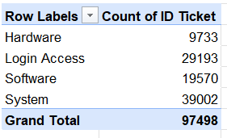

Question 5: How many tickets has each agent handled?

Solution:

Final Answer (if any):
1 1969
2 1968
3 2021
4 1988
5 2000
6 1949
7 1935
8 1960
9 1949
10 1974
11 1956
12 1897
13 1856
14 1942
15 1991
Approach (if any):
Pivot Table name Ticket Handle in Q5 sheet
Charts & Tables (if any):
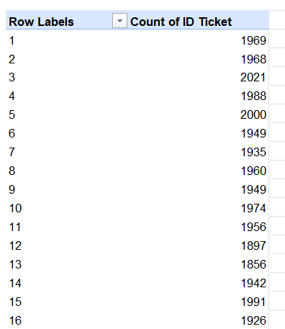

Question 6: How can you extract the domain from the email addresses in the IT Agents sheet?

Solution:

Final Answer (if any):
<Final answer or output>

Approach (if any):
Text to Column Method and used formula =LEFT(C8,FIND(".",C8)-1) to get domain name

Charts & Tables (if any):

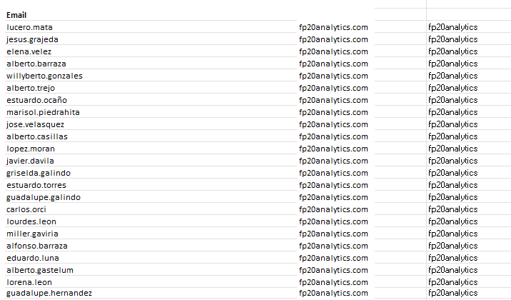

Question 7: How can you find the full name of an agent given their Agent ID?

Solution:

Final Answer (if any):
Agent Name is fetched using Agent I’D

Approach (if any):
=VLOOKUP(D2,'IT Agents'!A:B,2,0)
Charts & Tables (if any):
- Table / Chart Name:
<Name of the table or chart used>
- Description:
<What the table or chart represents>

Question 8: What is the count of each issue type (e.g., IT Error, IT Request)?

Solution:

Final Answer (if any):
IT Error 24278
IT Request 73220

Approach (if any):
=COUNTIF(Tickets!F:F,Tickets!F2)
=COUNTIF(Tickets!F:F,Tickets!F5)

Charts & Tables (if any):
- Table / Chart Name:
<Name of the table or chart used>
- Description:
<What the table or chart represents>

Question 9: What is the average resolution time for tickets?

Solution:

Final Answer (if any):
4.553149808

Approach (if any):
=AVERAGE(Tickets!I2:I97499)
Charts & Tables (if any):
- Table / Chart Name:
<Name of the table or chart used>
- Description:
<What the table or chart represents>

Question 10: How has the volume of tickets changed over time?

Solution:

Final Answer (if any):
it started from 13051 to last 29088

Approach (if any):
Pivot Table & Chart in Q 10 Sheet

Charts & Tables (if any):
Pivot Table Name: Volume Time
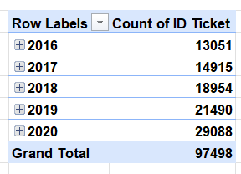
Chart Name: Volume Chart
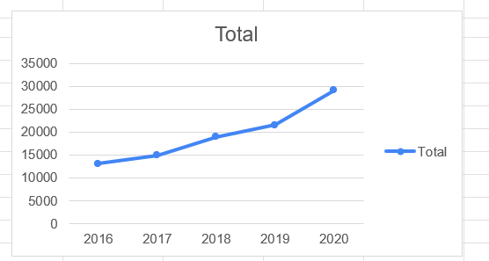

Question 11: What is the average age of the IT agents?

Solution:

Final Answer (if any):
41 is the Average age

Approach (if any):
- I created age column in IT Agent sheet using =DATEDIF(DATE(D2,E2,F2),TODAY(),"Y")
- Then I count average using =AVERAGE('IT Agents'!G2:G51)

Charts & Tables (if any):
- Table / Chart Name:
<Name of the table or chart used>
- Description:
<What the table or chart represents>

Question 12: Is there a correlation between the severity of issues and the resolution time?

Solution:

Final Answer (if any):
-0.040536349

Approach (if any):
First I look the left value of 1 character from severity then I converted into a number then performed.

Charts & Tables (if any):

Question 13: How many categorical columns are there in the data? [Search about categorical and continuous data, and try to answer this question]

Solution:

Final Answer (if any):
There are 16 Columns of categorical data and 1 Continuous Column between 2 Tables

Approach (if any):
<Methodology, logic, formulas, or steps used to arrive at the answer>

Charts & Tables (if any):
- Table / Chart Name:
<Name of the table or chart used>
- Description:
<What the table or chart represents>

SUBJECTIVE QUESTIONS

Question 1: If there is an investment, should it be used to hire more IT agents, improve training programs, or upgrade ticket management software?

Analysis: Perform a cost-benefit analysis using ticket resolution and satisfaction metrics.

Solution:

Approach:
Found an average of resolution and satisfaction and Tickets counts, with the priority wise ticket count and resolution.

Charts & Tables:
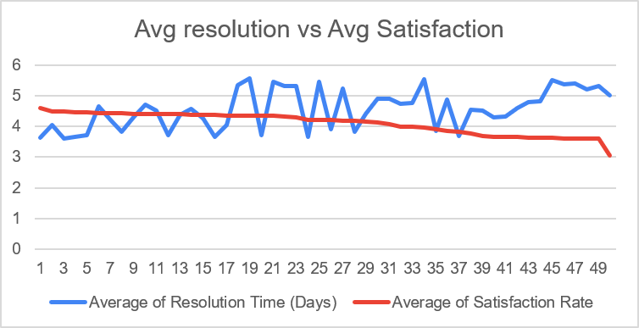

Insights:
On average, each IT agent handled approximately 1,949 tickets over the five-year period, indicating a manageable workload. The average ticket resolution time is around 4.5 days, while the average customer satisfaction rating stands at 4.10 out of 5. The analysis also shows that the number of unassigned tickets and high-priority tickets is significantly higher than other categories. Despite the higher volume, high-priority tickets have the shortest average resolution time, whereas low-priority tickets take the longest to resolve.
Recommendations:
Instead of hiring more IT agents, the organization should invest in enhancing employee training programs to improve technical skills and reduce average ticket resolution time. Additionally, implementing a more efficient ticket management system can streamline ticket assignment and tracking, leading to faster resolutions and improved customer satisfaction.

Question 2: Which agents need additional training based on their performance metrics?

Analysis: Identify agents with the lowest satisfaction ratings and longest resolution times.

Solution:

Approach:
Found an average of Each Agent’s Satisfaction, Resolution time. Then formatted the columns according to values which shows which agents are below the satisfaction average (4.10) and above the resolution time average (4.55)

Charts & Tables:
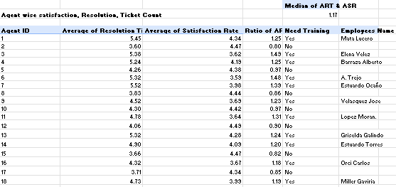

Insights:
Mata Lucero, Elena Velez, Barraza Alberto, A. Trejo, Estuardo Ocaño, Velasquez Jose, Lopez Moran., Griselda Galindo, Estuardo Torres, Orci Carlos, Miller Gaviria
Alfonso Barraza, Lorena, Sandra Lujan, Flores Sierra, Nurio Zepeda, Parra Luna, Silvia Morales, Guadalupe Villanueva, Jesus Pacheco, Jesus Contreras, Aldo Carrillo, Rosa Olguin, Armando Sierra, Ramon Macias. These are the employees who’s are not performing well and need improvement training.
Recommendations:
We recommend a prioritized training plan to improve the overall performance of IT agents. First, provide Ticket Prioritization & Severity Classification training for 2 weeks to reduce incorrect priority assignments by 20% and decrease the average resolution time from 4.55 days to below 4.3 days. Next, conduct Technical Troubleshooting (Hardware & Software Issues) training for 3 weeks to improve the first-time resolution rate by 15% and reduce repeat tickets. Finally, provide Customer Communication & Service Skills training for 1 week to increase the customer satisfaction score from 4.16 to above 4.30. The effectiveness of the training should be monitored using these measurable performance metrics.

Question 3: Do certain categories of requests have longer resolution times?

Analysis: Analyze the resolution times by request category.

Solution:

Approach:
Summarize each request category’s average resolution time, count of tickets, median, station deviation.
Charts & Tables:
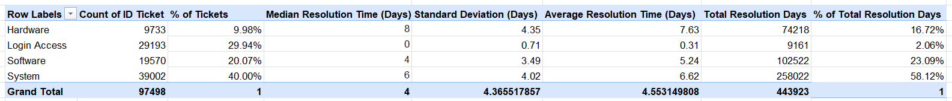

Insights:
As per the analysis, we can see that different request categories have different resolution times. Hardware requests take the longest to resolve, with an average resolution time of 7.63 days, even though they account for only 9.98% of the total tickets, which indicates that these issues are more complex. System requests contribute the highest number of tickets (40%) and also have a high average resolution time of 6.62 days, making them the biggest contributor to the overall support workload. On the other hand, Login Access requests are resolved the fastest, with an average resolution time of just 0.31 days, showing that the current process for these requests is highly efficient.
Recommendations:
The organization should focus on improving the resolution process for Hardware and System requests, as these categories have the greatest impact on overall resolution time. It should invest in improving troubleshooting procedures and provide additional training to IT agents so that complex issues can be resolved more quickly. The organization should also analyse recurring Hardware and System issues and take preventive measures to reduce ticket volume. By improving these processes, it can reduce the overall resolution time and improve customer satisfaction.

Question 4: How effective are the current software tools in managing IT tickets?

Analysis: Evaluate performance metrics before and after the implementation of new tools.

Solution:

Approach:
I evaluated the current system on basis of volume of ticket, customer satisfaction rating, resolution time, Priority and severity.
Charts & Tables:
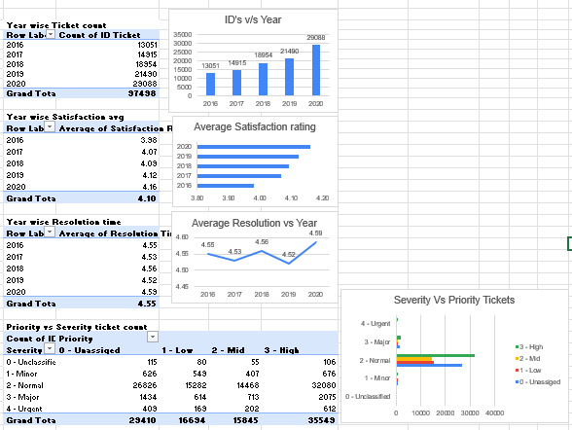

Insights:
As per the analysis, we can see that the current software tools are effectively managing IT tickets, as the average resolution time has remained stable at around 4.55 days despite the ticket volume increasing from 13,035 in 2016 to 29,088 in 2020. Customer satisfaction also improved from 3.98 to 4.16, indicating that the system has maintained service quality while handling a growing workload. However, the high number of High Priority tickets across different severity levels suggests that the current prioritization process can still be improved.
Recommendations:
Based on the analysis, we recommend improving the ticket prioritization process by implementing automated severity-to-priority mapping, where the system automatically assigns the correct priority based on the selected severity level. This will reduce manual errors and ensure tickets are categorized consistently. Validation alerts should also be added to notify agents if priority information is missing or incorrectly selected before submitting a ticket, helping improve data accuracy. Additionally, IT agents should receive targeted training on ticket prioritization, severity classification, and ITSM best practices to improve their decision-making and reduce incorrect ticket assignments. These improvements will help reduce resolution delays, increase workflow efficiency, and improve overall customer satisfaction.

Question 5: How has the performance of the IT support team changed over time (e.g., monthly or quarterly)?

Analysis: Trend analysis using time series charts.

Solution:

Approach:
I took the performance of quarter wise in every year with their average resolution time and satisfaction rating.
Charts & Tables:
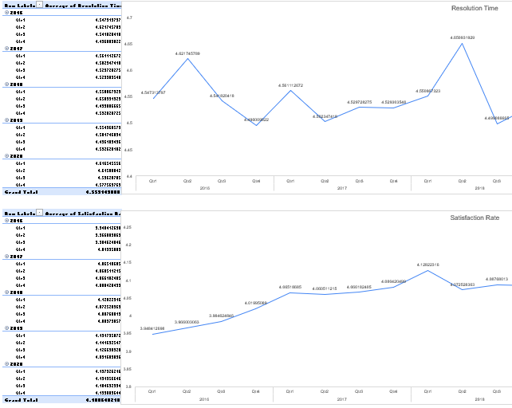

Insights:
The average resolution time fluctuates every quarter, while customer satisfaction generally shows a consistent upward trend. Despite a slight dip in one period, it recovered quickly and achieved its highest ratings thereafter.
Recommendations:
We need to focus on training programs to minimize the average resolution time and little bit focus in satisfaction rating as it 3.8 to 4.2.

Question 6: If we invest more on tech (Hardware, software, etc), do you think it will improve the ticket resolution times and employee satisfaction?

Analysis: Use historical data to project potential improvements.

Solution:

Approach:
I tried to understand request category wise data like how many tickets have each category have, what is resolution time, rating this all

Charts & Tables:
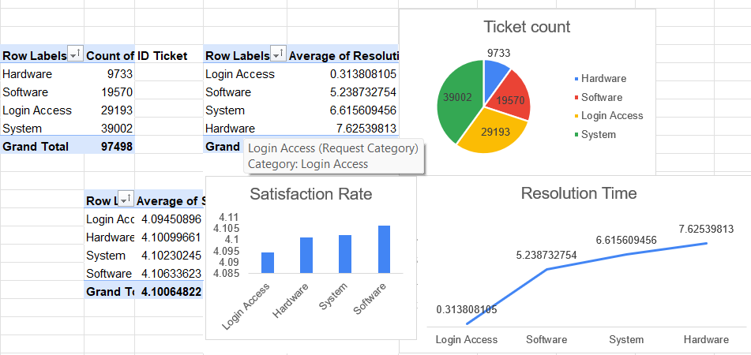

Insights:
We can see that the resolution time of hardware category is highest but it also have a lowest amount of ticket volume and rating is stable, as we see that system category have highest ticket volume but it has more than average resolution times, we have login access category which contains more than 29k ticket volume but it has the lowest resolution time which is best category but it also has the lowest satisfaction which need improvement, we see the system category which have the highest volume of ticket but it have moderate amount of resolution time and an average satisfaction.

Recommendations:
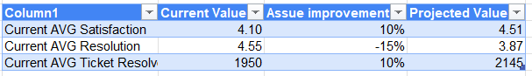
Due to improved hardware, updated software, IT agents are expected to resolve more tickets within the same time period, increasing the number of tickets resolved by approximately 10%, while reducing the average resolution time by 15% and improving customer satisfaction by 10%.

Question 7: What are the key performance metrics for IT agents, and how can they be improved, do we need to fire any agents?

Analysis: Define and analyze metrics such as average handling time, satisfaction scores, and number of tickets resolved.

Solution:

Approach:
I took agent wise data of no. of ticket handling, average satisfaction rating, average resolution time then I took a common average of these column then I used conditional formatting to highlight the cell on less than average value.
Charts & Tables:
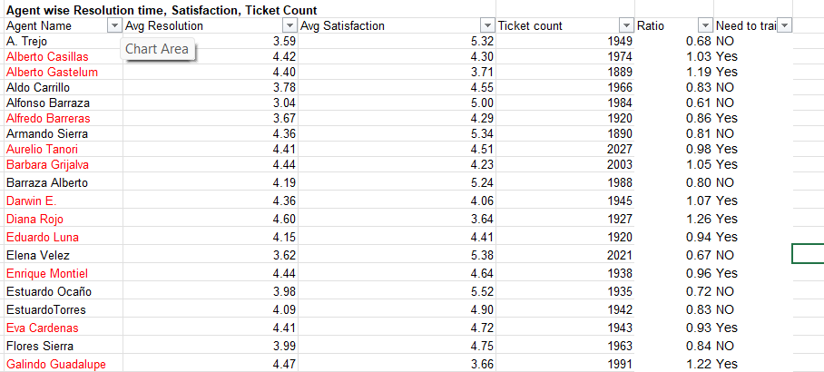
Insights:
Alberto Casillas, Alberto Gastelum, Alfredo Barreras, Aurelio Tanori, Barbara Grijalva, Darwin E., Diana Rojo, Eduardo Luna, Enrique Montiel, Eva Cardenas, Galindo Guadalupe, Guadalupe Hernandez, Guadalupe Torrico, Isela Leyva, Javier D., Jesus Grajeda, Leon Lourdes, Luis Arguello, Luis Torres, Marisol Piedrahita, Melinda, Reyna Santacruz, Segura Garcia, Willyberto Gonzales, Yomaira Agudelo. This are the employees to whom we need to focus on first we should give them a chance by giving a training and observe for 3 months if then also they didn't perform well then we need to fire them.
Recommendations:
Based on the analysis, we found that 25 IT agents have a Solution Ratio above the median value of 0.85, which indicates that they are taking more time to resolve tickets compared to other agents. We recommend focusing on these agents first by providing targeted training on technical troubleshooting, ticket prioritization, and time management. Their performance should be monitored for the next 3 months, with the goal of reducing their Solution Ratio below 0.85, improving customer satisfaction, and reducing their average resolution time. If they still fail to meet the required performance standards after the training and monitoring period, management can consider replacing or terminating them based on the company's performance policy.

Question 8: How do employee demographics (e.g., department, seniority) impact satisfaction and ticket outcomes?

Analysis: Segment analysis using filters and pivot tables.

Solution:

Approach:
I took age group data then saw age group wise resolution time, satisfaction rating, ticket volume.
Charts & Tables:
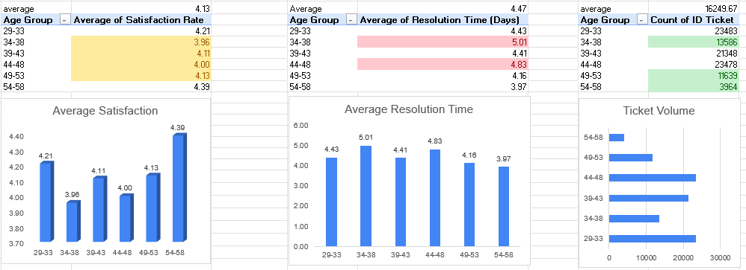
Insights:
As per the analysis, we can see that employee demographics affect both customer satisfaction and ticket outcomes. The 34–38 age group has the lowest customer satisfaction rating (3.96) and the highest average resolution time of 5.01 days. On the other hand, the 54–58 age group has the highest customer satisfaction rating (4.39) and the lowest average resolution time of 3.97 days. We can also see that the 29–33 age group raises the highest number of tickets, which means they contribute the most to the overall IT support workload. This shows that different employee groups have different support experiences.
Recommendations:
The organization should focus on reducing the resolution time for the 34–38 age group so that customer satisfaction can be improved. It should also analyse why the 29–33 age group raises the highest number of tickets and identify recurring issues to reduce ticket volume. By understanding the support needs of different employee groups and improving the ticket handling process, the organization can increase customer satisfaction and improve overall IT support efficiency.

Question 9: Identify the trends for IT support operations based on ticket volumes and satisfaction, and mention the peak and stable times?

Analysis: Use pivot tables and charts to identify peak and off-peak hours.

Solution:

Approach:
I took the year-month wise data of satisfaction rate and ticket volume.

Charts & Tables:
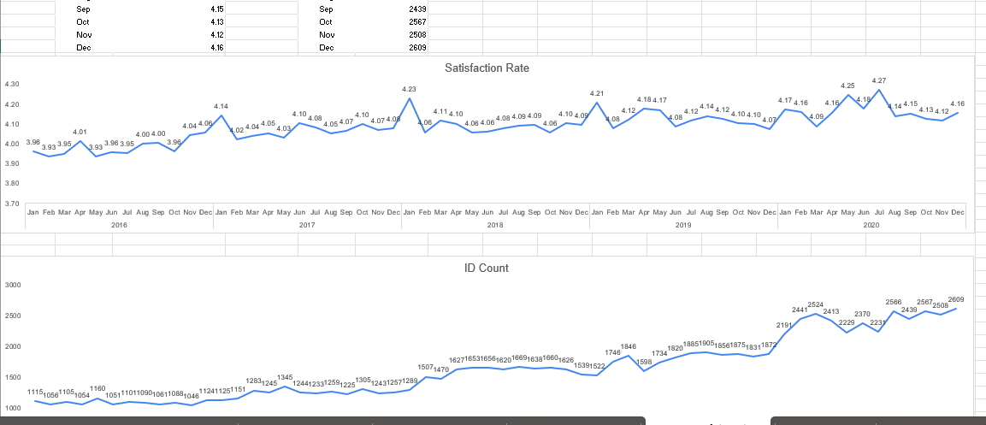
Insights:
We can analysis that the peak months of ever year according to ticket counts are (2016,2017-May), (2018,2019-Aug), (2020-Dec), and according to peak satisfaction (2016-Dec), (2017,2018,2019-Jan), (2020-Jul).

Recommendations:
We can analysis that every year the counts of tickets at peak on a range between 1160 to 2609 and which is good improvement as increased by 1449 but the satisfaction peak is of 4.06 to 4.21 which can be improved more.

Question 10: What metrics should be included in the final dashboard to provide a comprehensive view of call center performance and guide investment decisions?

Solution:

Approach:
We have to see the Month & Year wise Ticket volume, Month & Year wise Satisfaction rate, Request category wise ticket volume, Category & Quaterwise resolution time, Satisfaction by age group, Serverity by tickets, Resolution time by ticket count, Tickets by satisfaction score. And Slicers with Years, Priority, Severity, Issue Type and Request Category.
Charts & Tables:
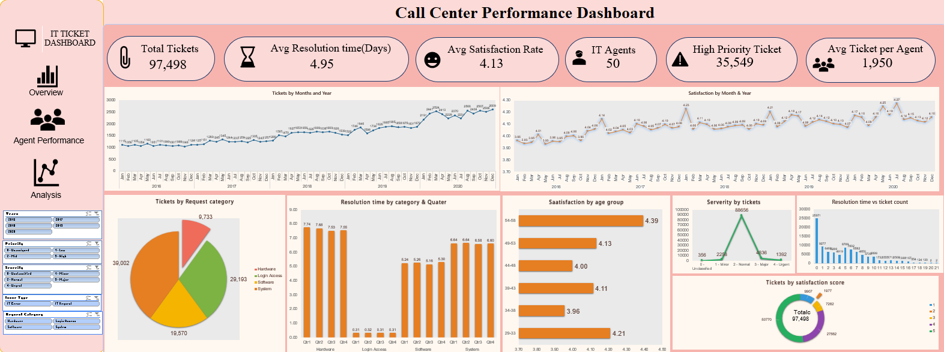
Insights:
<Key observations derived from the data>

Recommendations:
<Actionable recommendations based on the insights>

